roid

217, Sheikh Rashid Building

P.O Box 56272, Dubai

United Arab Emirates

Tel: +971 4 2973236 / 04 2974007

Email: uae@verbat.com

PROJECT   
PROPOSAL

**Licensing and Classification System**

|  |  |
| --- | --- |
| **Prepared for:**  **Ahmed Obaid Al Tunaiji** | **Submission Date:**  22 May 2017  **Proposal ID:** AD/BP/22052017/1343/1 |

___________________________________________________________________________________________________________________________________________  
Conﬁdentiality Notice: This Proposal is conﬁdential and contains proprietary information and intellectual property of Verbanet Technologies LLC. Neither this proposal nor any of the information contained herein may be reproduced or disclosed under any circumstances without the express written permission of Verbanet.

© 2017 by Verbanet Technologies LLC. All rights reserved. Confidential.

___________________________________________________________________________________________________________________________________________

Project Contacts

|  |  |
| --- | --- |
| Client Information | |
| Project Name | Licensing and Classification System |
| Client Name | Sharjah Commerce and Tourism Development Authority |
| Client Address | Buheira Corniche Road - Sharjah - United Arab Emirates |
| Contact Person | Mr. Ahmed Obaid Al Tunaiji |
| Contact Person Email | Ahmed.ot@Sharjahtourism.ae |
| Contact Person Phone Number | 9 716 519 0961 |
| Verbat Information | |
| Contact Person | Joyce Daniel |
| Contact Person Phone Number | +971 42973236 |
| Contact Person E-Mail | [joyce.daniel@verbat.com](mailto:joyce.daniel@verbat.com) |
| Address | PO Box 56272, Dubai, United Arab Emirates |
| Physical Address | 217, Sheikh Rasheed Building, Hor Al Anz East |
| Project Information | |
| Proposed Technology/Methodology | C#, MSSQL, MVC, CSS, JQUERY, HTML |
| Anticipate Start Date | NA |
| Proposal Valid For | 30 Calendar days from the submission of the proposal |

**Table of Content**

1 Intoroduction 7

1.1 Background 7

1.2 Overview of Tourism Standard Department (TSD) 7

1.3 Objectives of Licensing and Classification Services (LCS) 8

2 Scope 8

2.1 Key Platform Stakeholders / “Actors” 9

2.2 Proposed Solution Model 11

2.3 Solution Objective 11

2.3.1 Primary Approval for trade license for new hotel 14

2.3.2 Approval for modification of building plan 15

2.3.3 Primary Approval for Trade License Renewal 17

2.3.4 Approval for Trade Name 18

2.3.12 Approval for Hotel Name Change 19

2.3.13 Issuance of Primary Approval for Hotel/Hotel Apartment Operation Resumption 21

2.3.14 Issuance of Primary approval for Trade License Cancellation of the Hotel/Hotel Apartment 22

2.3.15 Approval for hotel Management License 23

2.3.16 Approval for Tour Operator License 24

2.3.22 Approval for New Tour Guide License 25

2.3.24 Reprinting/Replacement of Issued Tour guide License Card 26

2.3.25 Fine Issuance and Collection/Payment 27

2.3.26 Toursim Inspection and Classification Services 28

1.3.26.1 Hotel/Hotel Apartment Inspection 28

2.3.27 Languages 32

2.4 Advantages of Proposed Solution 32

2.5 Why Verbat 33

2.6 Key Differentiators 34

2.7 Technology & Services 35

3 Functional Specification 36

4 High Level Design 40

4.1 Use case Diagrams 40

4.2 Data Flow Diagram 42

4.3 Workflows 43

4.4 Generic Workflow 44

4.5 Functional Architecture 45

4.6 Application Level features 46

4.7 System Level Features 47

4.8 High Level Architecture 49

5 Nonfunctional Requirement (Others) 51

6 Assumptions 51

7 Out of Scope 52

8 Technology Solution 53

8.1 Proposed System Environment 53

8.2 Technical Configurations 54

8.2.1 Development Tools 54

8.2.2 Recommended Web Hosting Package 54

8.2.3 Browser Compatibility 54

8.2.4 Hardware Interface 54

9 Commercials 55

9.1 Web Application 55

9.2 Payment Terms 55

9.3 Mode of Payment 55

10 Delivery Management 56

10.1 Project Management 56

10.2 Roles and Responsibilities 56

10.3 Delivery Activity Summary 58

10.4 Project Implementation Plan 58

10.5 Deliverables 59

10.6 Estimated Delivery Time 59

10.7 Deployment Details (at Clients Behest) 61

10.8 Release Planning 61

10.9 Risk and Contingency Planning 61

11 Change Management 62

12 Miscellaneous 64

12.1 Acceptance Criteria 64

12.2 General Terms and Conditions 64

12.3 Assumptions and Dependencies 65

12.4 Source Code & Intellectual Property Rights 66

12.5 Maintenance & Support 66

12.6 Service Level Agreement 67

13 Our Clients 68

# Introduction

## Background

Sharjah Commerce and Tourism Development Authority (Hereafter referred to as the “Client”) was established in 1996 by virtue of the Emiri Decree No. (5), with the objective of promoting

Commercial and tourism activities in the Emirate. The Authority endeavors to develop these sectors through various events, activities and issuances, and promotes the emirate at all local, regional and international levels.

The Authority carries out all the work and activities necessary to achieve their goals by way of planning and drawing up strategic plans to further development and to promote the tourism industry in all its forms; in addition to conducting related social and economic studies. It compiles the policies for participating in the local, regional and international exhibitions. The Authority also aims at marketing and promoting Sharjah to attract foreign investment.

In coordination with other government departments and the concerned private sector entities, SCTDA exerts a considerable effort in order to achieve the development intended for the Emirate of Sharjah, which is ranked among the most prestigious and distinguished commercial and tourist destinations in the region

## Overview of Tourism Standard Department (TSD)

The Tourism Standard Department (TSD) provides one of the major core services of SCTDA. The Department focuses on enhancing efficiency in the tourism sector that would promote Sharjah as a world-class destination, providing excellent facilities and capabilities by formulating standards of tourism oriented establishment. The TSD initiates various government regulations to ensure that the quality of tourism related services and products in Sharjah would be maintained and improved to align with the international standards and creating sustainable services and products for tourists. The TSD has its licensing services, inspection and classification of tourism accommodations, permit issuance of tourism business and activities among others to oversee quality assurance, safety and sustainability of tourism products. Studies and research are also conducted periodically for future enhancement and improvement in the execution and application of its current tools and methodology enforced, validating current operation with the international/regional best practice in tourism services, adopt strategic cooperation and joint ventures. In line with improving the delivery of its services, the TSD continuously upgrade also its platform and e-system to minimize processing time and provide excellent and convenient service to its stakeholders in license/permit application, issuing, renewing, payments, communications, etc. This would level up customer service for better customer satisfaction, achieving as well the government SMART goals.

## Objectives of Licensing and Classification Services (LCS)

* To provide a one-stop gateway to perform a multifunction licensing, classification, inspections, and fines processing and transactions as detailed in the Annexure A, B, and C;
* To reduce the processing time and to create a Solution structure to efficiently regulate and control the entry and management of licensing, classifications, inspections, and fines to the hotels, hotels apartments, and tour operators in the Emirate of Sharjah.

# Scope

The scope of work is to provide a comprehensive solution that is hosted in SCTDA data center to automate all the transactions of the specified services mentioned in the Annexure A, B, and C to achieve the objectives of the Project.

The services and workflows mentioned in the Annexures are high level and they don’t specify the detailed workflow. Verbat shall collect the detailed transactions, workflow, fields, and conditions etc. and document them in the Software Requirement specifications. Verbat shall execute the project after getting approval from SCTDA. The provided Solution shall support different kinds of workflow (acceptance, rejection, notifications through SMS (Gateway to be provided by SCTDA) and email

* The system shall be integrated with the “Tahseel Payment Gateway” to enable the customers to pay the fees/fines of the Services online
* The solution must enable the external customers to register themselves to avail the services offered.
* The interface of the provided solution shall be built in HTML 5 responsive design
* .The letters, licenses and receipts issued by LCS will not have a handwriting signature, instead all of them shall have a reference number with QR code or barcode
* The Service Provider shall work with SCTDA to define the format of the letters, receipts, reports, and licenses
* The inspection services and workflows shall include the development of and iOS app to be used in iPads by the inspectors to perform the inspections
* The app shall have the ability to work offline where it sync all the tasks, criteria, and needed information of the hotels and their violations from the server while its connected to the internet, where it can use this information to perform the inspections and fines and then sync them to the server when the internet is connected.
* System shall provide user friendly Reports

Verbat is pleased to submit the proposal and values it as a great opportunity to have a long term & mutually beneficial association with the client. Verbat has gone through the requirement and presents a proposal for the requested system.

## Key Platform Stakeholders / “Actors”

1. **Applicants:** Users from the general public who are trying to receive a new permit or trying to renew their permits.
2. **TSD Licensing staff:**  Verification of the documents provided as proof are validated by licensing staff. They may defer the approval of the application to the head of licensing.
3. **Licensing Heads:** Reviewing the licensing check list and recommending approval/rejection to the TSD Manager.
4. **TSD Manager:** Dispute resolution or cases where vehicles need to be inspected are deferred to the manager. Manager can issue new permits as well as assign cases to the vehicle inspectors
5. **Inspectors:** Inspectors inspect hotel/hotel apartments based on an inspection checklist. Inspectors will log the results of the inspection along with evidence, in the application, which will be made available to the TSD manager.
6. **Inspection Heads:** Verifies the inspection results
7. **Other Stakeholders**: IPTD Staff, Licensing Division Staff and Internal Auditors
8. **System:**  The system has intelligence built into it that can identify hotel/hotel apartments that need to be inspected soon, permits that are nearing expiration etc. The system will issue appropriate alerts, mails and SMS messages to the concerned. System can automatically disable access to accounts that expired or cancelled their application

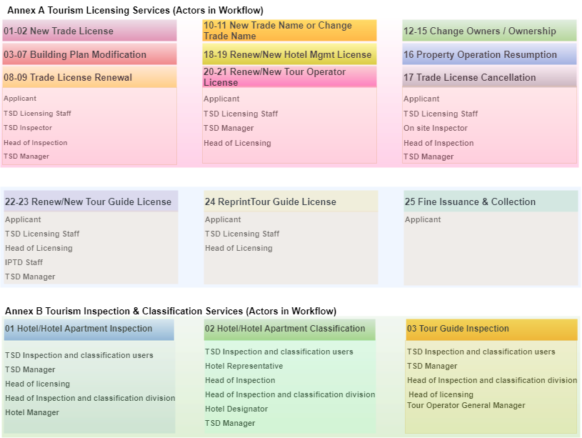

## Proposed Solution Model

**Stand-Alone Fixed Bid**

Verbat will be following a stand–alone fixed bid solution delivery model wherein the required solution would be devised and a suitable pricing would be offered.

## Solution Objective

Verbat Intends to build the application based on the RFP provided by the client. Specifically the following workflows and forms shall be considered as the primary development activity

**Annex A: Tourism licensing Services**

* New Issuance of Primary Approval to Obtain Trade License for a New Hotel/ Hotel Apartment
* Re-Issuance of Primary Approval to Obtain Trade License for a New Hotel/Hotel Apartment
* Issuance of Primary Approval for Modification in the building plans/drawings of new (for construction/under construction) hotel/hotel apartment
* 0Issuance of Primary Approval for Modification in the building plans/drawings of an existing and operating hotel/ hotel apartment to make changes in the interior/exterior structure (i.e. rooms, public area, restaurant, facilities, etc.)
* Issuance of Primary Approval for Modification in the building plans/drawings for hotel/hotel apartment building structure expansion (vertical/horizontal)
* Issuance of Primary Approval for Modification in the building plans/drawings to change trade activity, conversion from hotel to hotel apartment and vice versa
* Issuance of Primary Approval for Modification in the building plans/drawings to convert new existing building to a 4- or 5-star hotel/hotel apartment
* Issuance of Primary Approval for Trade License Renewal of Existing and operating Hotel/Hotel Apartment
* Issuance of Primary Approval for Trade License Renewal of Existing Hotel/Hotel Apartment that are in the process to operate or not yet in operation
* Issuance of Primary Approval to Obtain Official Trade Name for Hotel/Hotel Apartment
* Issuance of Primary Approval to Change Official Trade Name for Hotel/Hotel Apartment
* Issuance of Primary Approval to Change in Hotel/Hotel Apartment Owner
* Issuance of Primary Approval to Change in Hotel/Hotel Apartment Partners (Addition)
* Issuance of Primary Approval to Change in Hotel/Hotel Apartment Partners (Withdrawals)
* Issuance of Primary Approval to Change in type of ownership, i.e. company to individual and vice versa, etc.
* Issuance of Primary Approval for Hotel/Hotel Apartment Operation Resumption
* Issuance of Primary Approval for Trade License Cancellation of the Hotel/Hotel Apartment
* Issuance of Primary Approval to Obtain a New Hotel Management License
* Issuance of Primary Approval for the Renewal of Hotel Management License
* Issuance of Initial Approval to obtain a New Tour Operator Trade License
* Issuance of Initial Approval for the Renewal of Tour Operator Trade License
* Issuance of Initial Approval to Obtain a New Tour Guide License
* Issuance of Initial Approval for the Renewal of Tour Guide License
* Reprinting/Replacement of Issued Tour Guide License Card
* Fines Issuance and Collection/Payment

**Annex B Tourism Inspection and Classification Services**

* Hotel/Hotel Apartment Inspection
* Hotel/Hotel Apartment Classification
* Tour Guide Inspection

**Annex C Application Forms**

* SCTDA-TS-SRV-1
* SCTDA-TS-A001
* SCTDA-TS-A002
* SCTDA-TS-A003
* SCTDA-TS-A004
* SCTDA-TS-A005
* SCTDA-TS-A006
* SCTDA-TS-A007
* SCTDA-TS-A008
* SCTDA-TS-A009
* SCTDA-TS-B001
* SCTDA-TS-B002
* SCTDA-TS-B003
* SCTDA-TS-B004
* SCTDA-TS-B005
* SCTDA-TS-B006
* SCTDA-TS-B007
* SCTDA-TS-B008
* SCTDA-TS-B009
* SCTDA-TS-B010
* SCTDA-TS-B011
* SCTDA-TS-B012
* SCTDA-TS-B013
* SCTDA-TS-B014
* SCTDA-TS-C001
* SCTDA-TS-C002
* SCTDA-TS-C003
* SCTDA-TS-C004

Verbat intends to build a one stop solution to manage and process permits for hotel/hotel apartments used by tourist. The system shall automate the process thus reducing turnaround times and increasing efficiency. The system will provide tools for application processing, printing of permits & stickers, fee calculation & collection, and reporting. The salient features of the application to be developed are noted below

### Primary Approval for trade license for new hotel

#### New issuance of primary approval to obtain trade license for a new Hotel/Hotel apartment

#### Re-issuance of primary approval to obtain trade license for a new Hotel/Hotel apartment

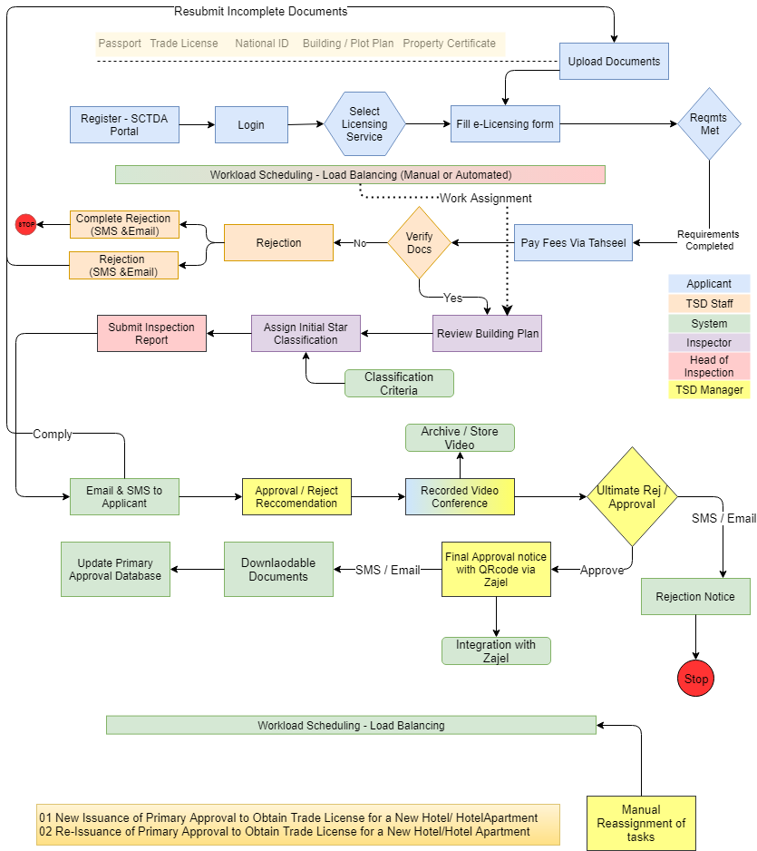

### Approval for modification of building plan

#### Issuance of primary approval for Modification in the building plans/drawings of new (for construction/under construction) hotel/hotel apartment

#### Issuance of primary approval for Modification in the building plans/drawings of an existing and operating hotel/hotel apartment to make changes in the interior/exterior structure (i.e. rooms, public area, restaurant facilities, etc.)

#### Issuance of primary approval for Modification in the building plans/drawings for hotel/hotel apartment building structure expansion (vertical/horizontal)

#### Issuance of Primary Approval for Modification in the building plans/drawings to change trade activity, conversion from hotel to hotel apartment and vice versa.

#### Issuance of Primary Approval for Modification in the building plans/drawings to convert new existing building to a 4- or 5-star hotel/hotel apartment

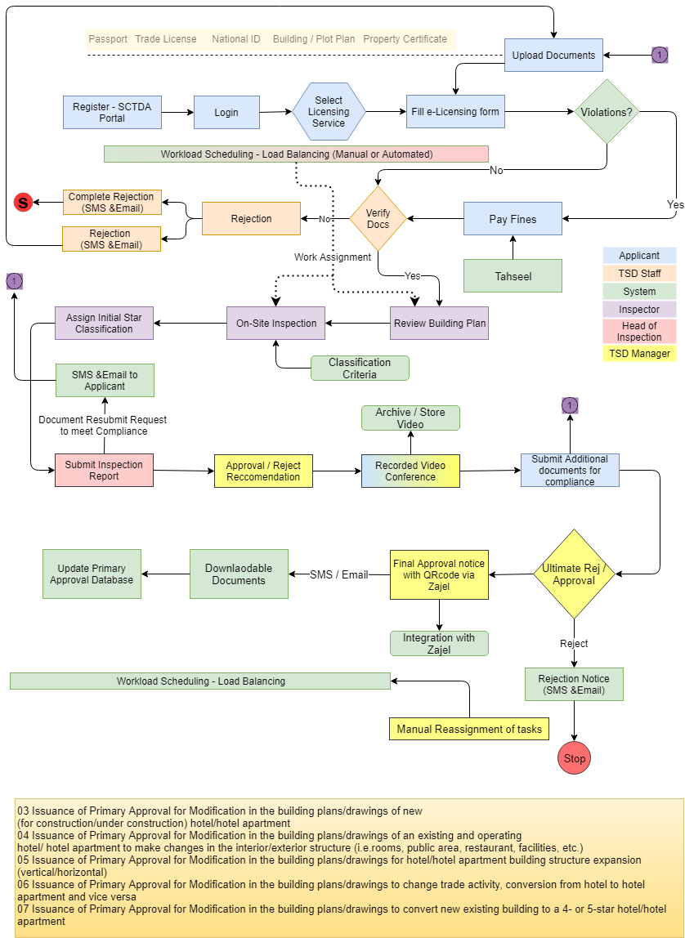

### Primary Approval for Trade License Renewal

#### Issuance of Primary Approval for Trade License Renewal of Existing and operating Hotel/Hotel Apartment

#### Issuance of Primary Approval for Trade License Renewal of Existing Hotel/Hotel Apartment that are in the process to operate or not yet in operation

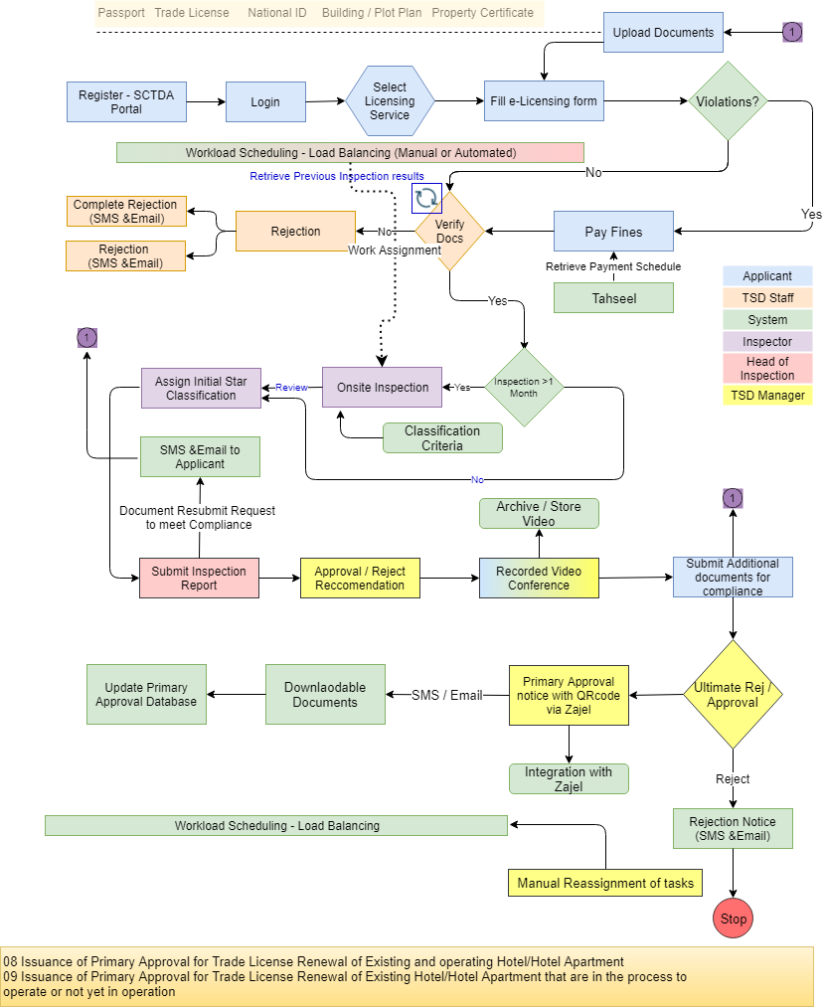

### Approval for Trade Name

#### Issuance of Primary Approval to Obtain Official Trade Name for Hotel/Hotel Apartment

#### Issuance of Primary Approval to Change Official Trade Name for Hotel/Hotel Apartment

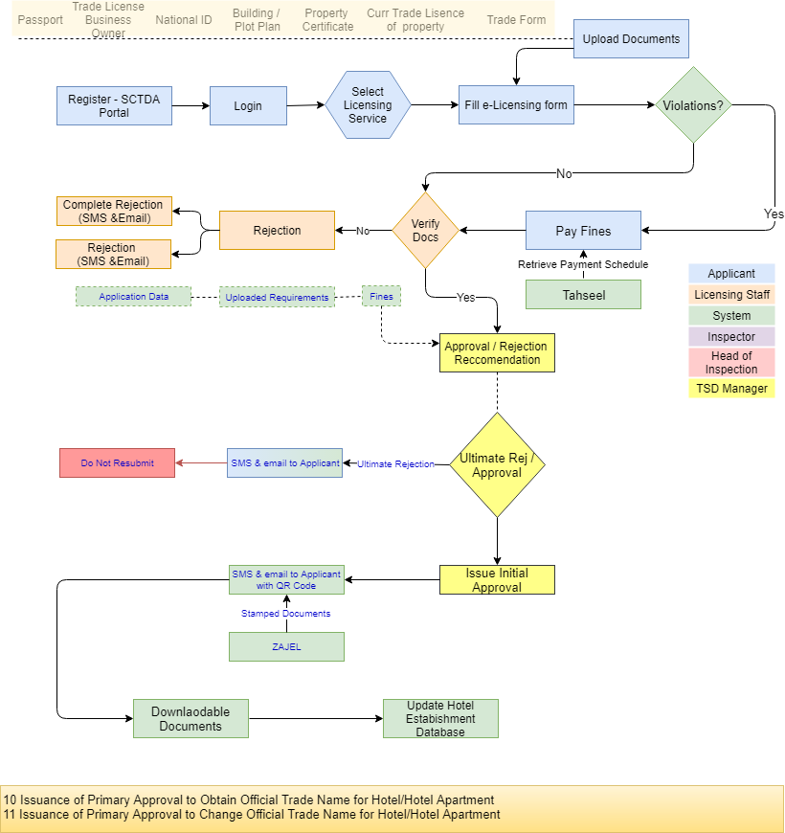

### Approval for Hotel Name Change

#### Issuance of Primary Approval to Change in Hotel/Hotel Apartment owner.

#### Issuance of Primary Approval to Change in Hotel/Hotel Apartment Partners (Addition).

#### Issuance of Primary Approval to Change in Hotel/Hotel Apartment Partners (Withdrawals)

#### Issuance of Primary Approval to change in type of ownership, i.e. company to individual and vice versa, etc.

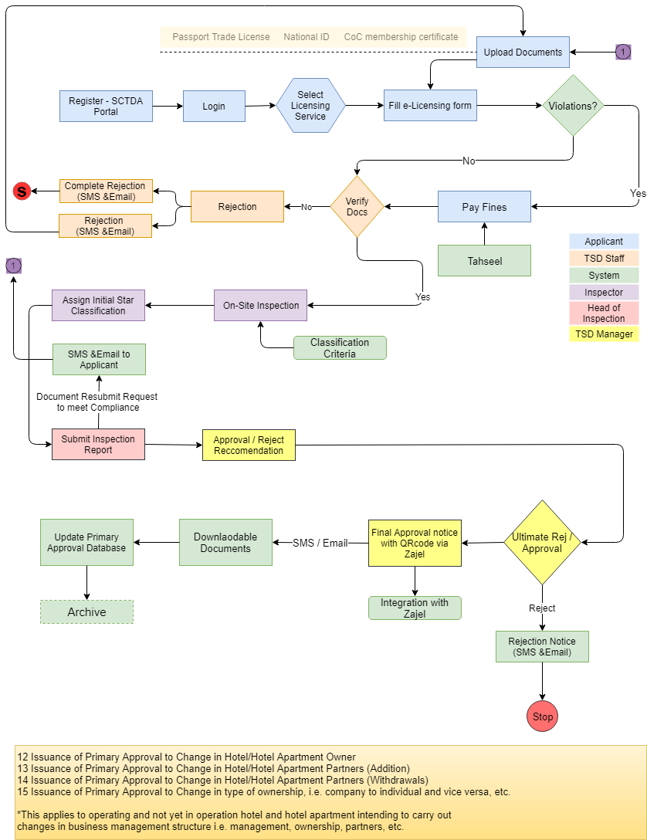

### Issuance of Primary Approval for Hotel/Hotel Apartment Operation Resumption

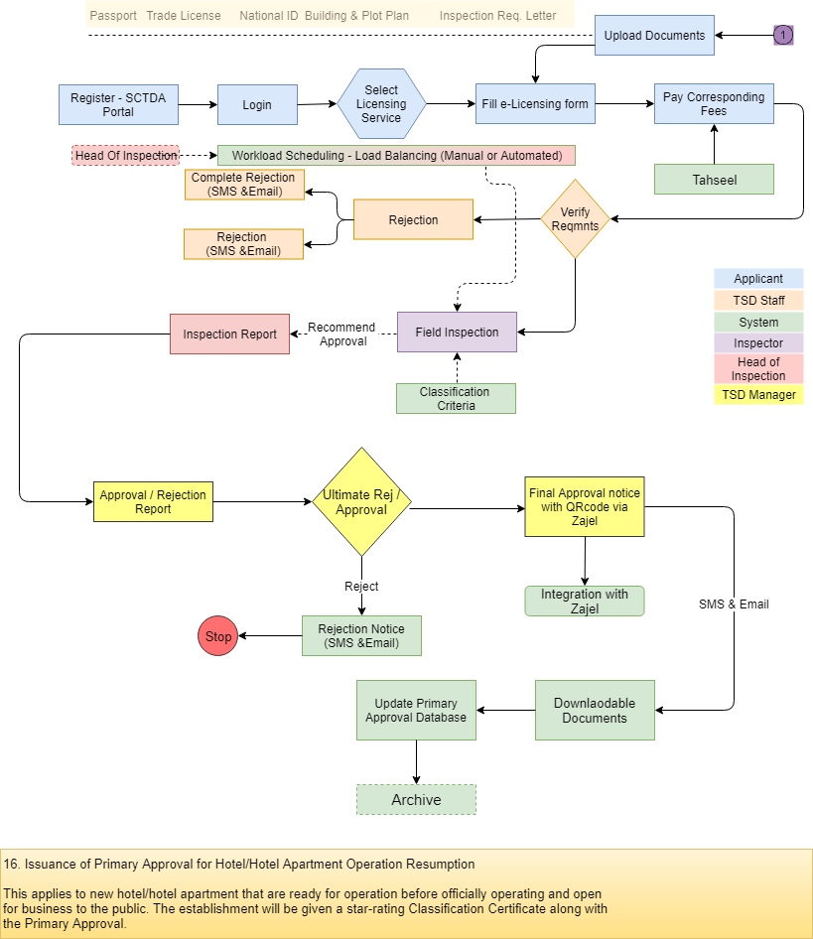

### Issuance of Primary approval for Trade License Cancellation of the Hotel/Hotel Apartment

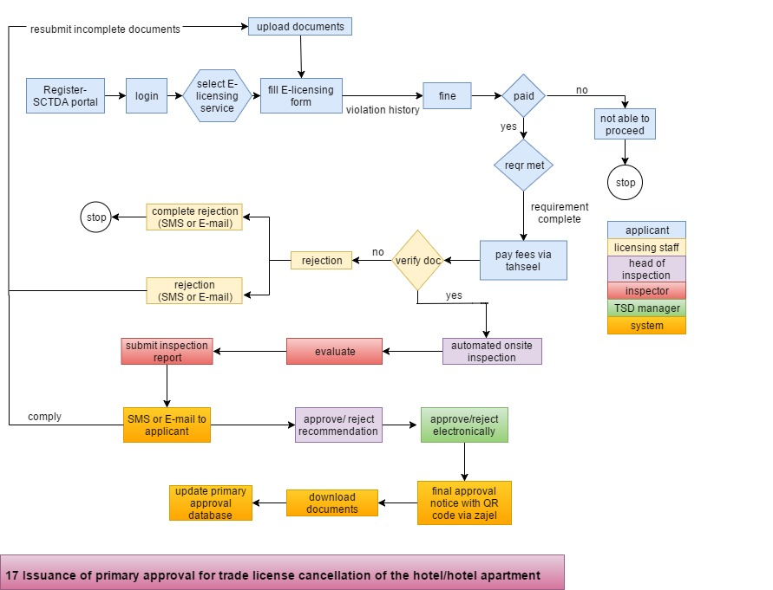

### Approval for hotel Management License

#### Issuance of Primary Approval to Obtain a Hotel Management License

#### Issuance of Primary Approval for the renewal of Hotel Management License

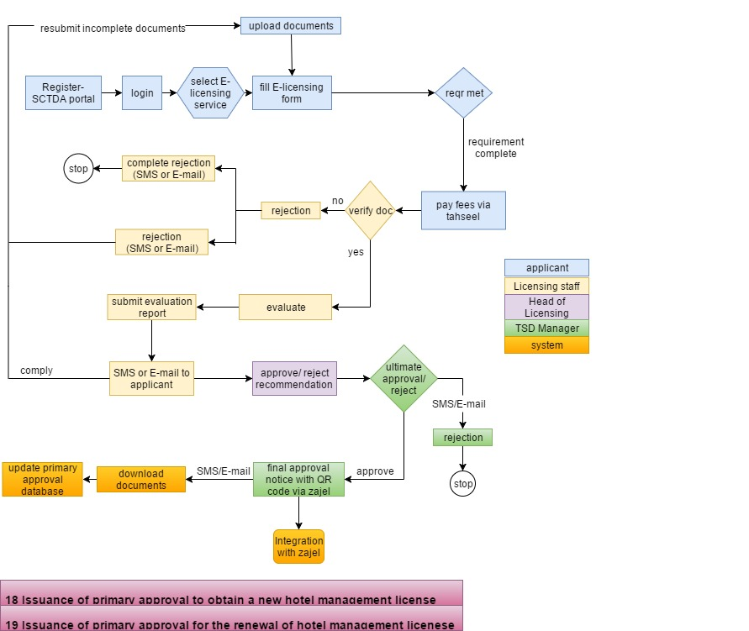

### Approval for Tour Operator License

#### Issuance of Initial Approval to obtain a New tour Operator Trade License

#### Issuance of Initial Approval for the Renewal of Tour Operator Trade License

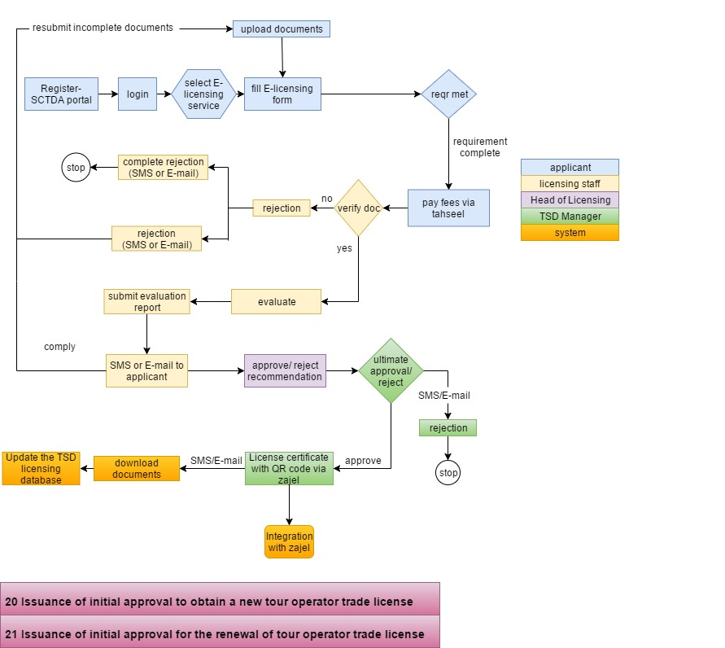

### Approval for New Tour Guide License

#### Issuance of Initial Approval to Obtaina a New Tour Guide License

#### Issuance of Initial Approval for the Renewal of Tour Guide License

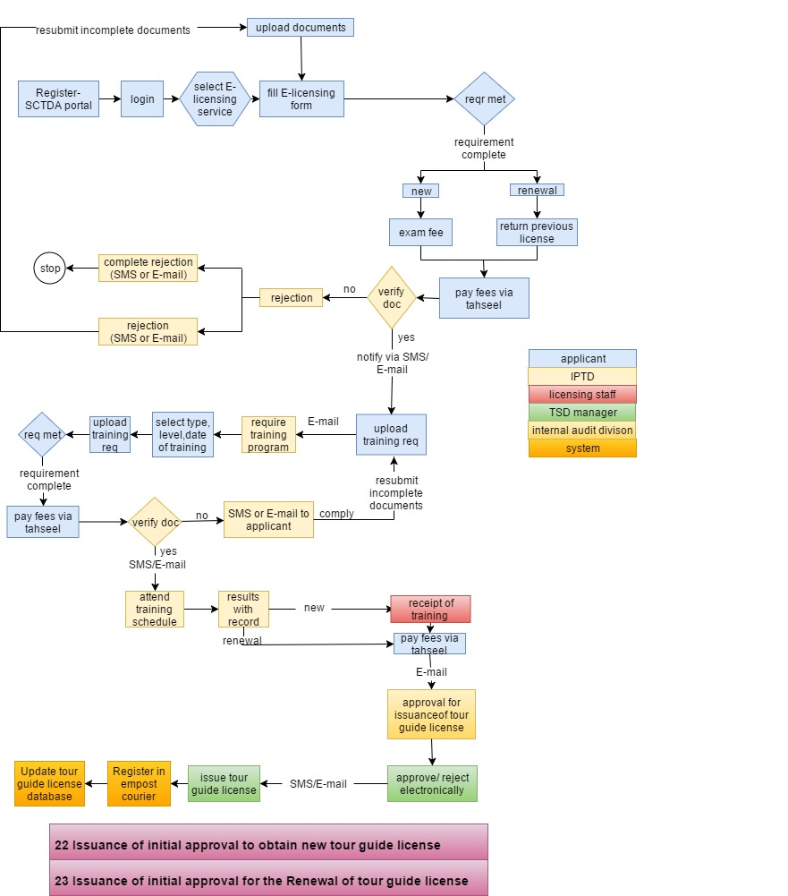

### Reprinting/Replacement of Issued Tour guide License Card

### Fine Issuance and Collection/Payment

### Toursim Inspection and Classification Services

### 1.3.26.1 Hotel/Hotel Apartment Inspection

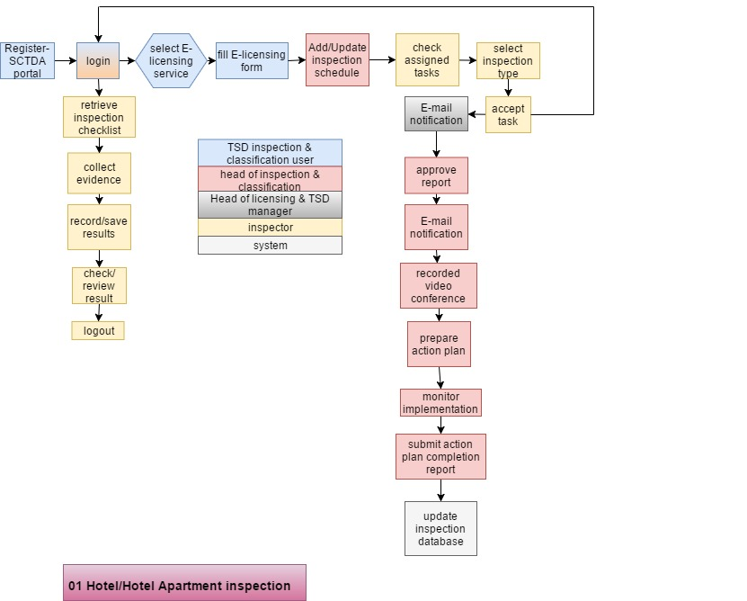

1.3.26.2 Hotel/Hotel Apartment Classification

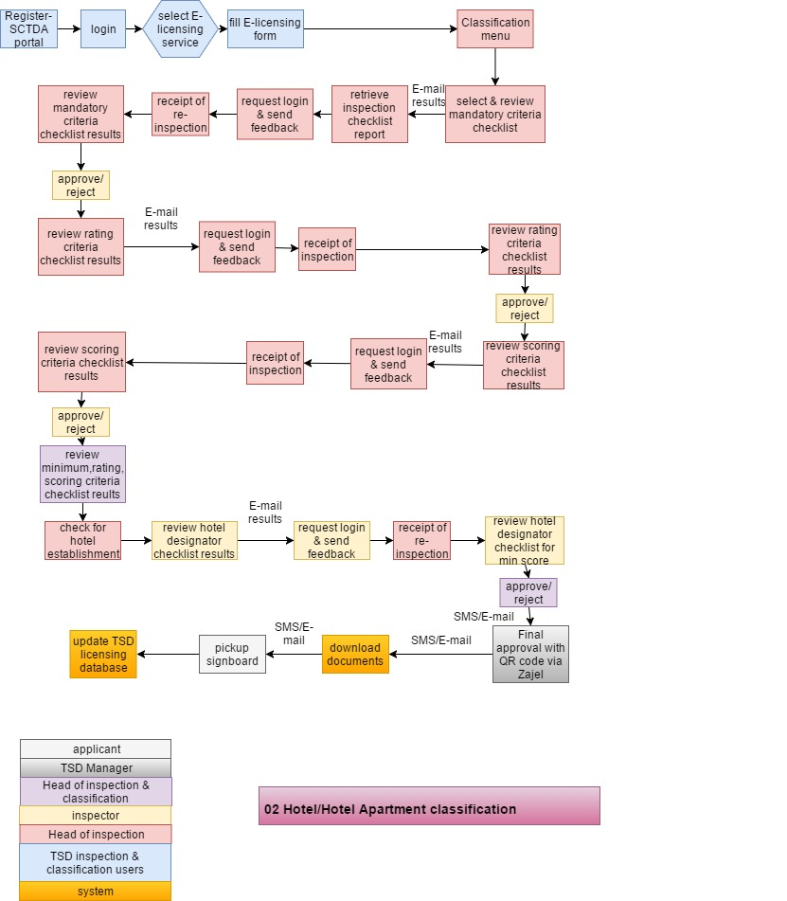

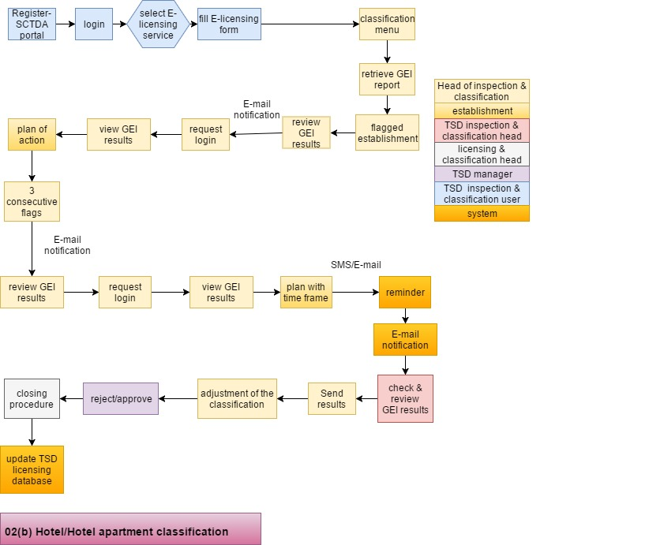

1.3.26.3 Tour Guide Inspection

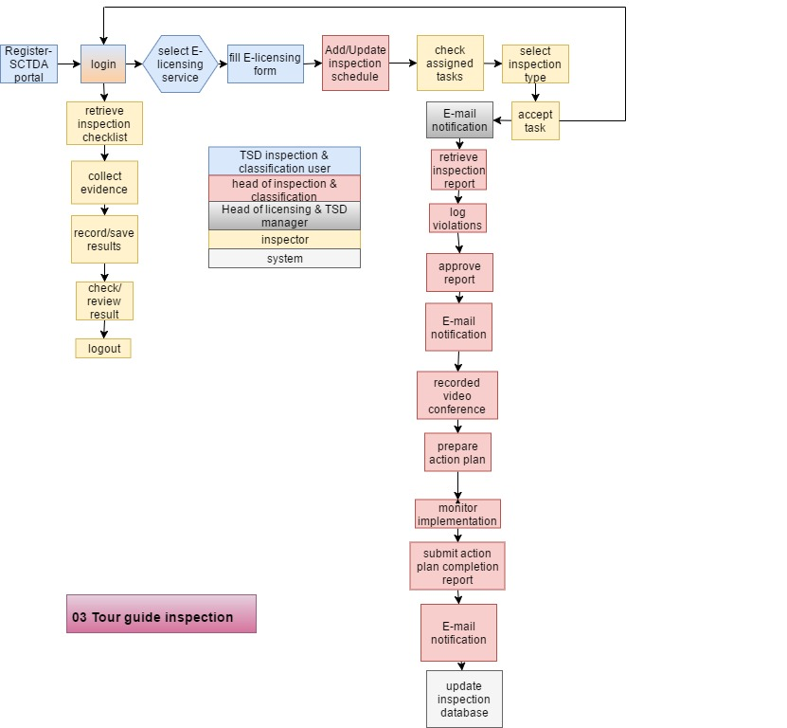

### Languages

* English & Arabic

Detailed requirements will be covered in the section titled “Functional Specifications”

Verbat’s Solution architects have conducted a thorough research on the requirements and have come to the conclusion that our proposed solution, which is detailed further in this document, will meet the requirements put forth by the client. And the proposed solution will be delivered in a phased approach as per Verbat’s stand-alone fixed bid solution model.

**Strong and Scalable platform:** The platform proposed will be strong and scalable enough to accommodate future enhancements.

**Accelerated solution:** The framework would act as a solution accelerator. It would provide the basic building blocks which could be reused in future for building new components and features.

**High performance:** The light weight framework used consumes fewer system resources thereby making the application perform faster.

**Security:** The application will be developed considering various aspects of security.

## Advantages of Proposed Solution



01

Agile development offering reliable, secure solution

02

Smooth transition and quicker completion of processes

03

User friendly interfaces enabling easy navigation between screens

## Why Verbat

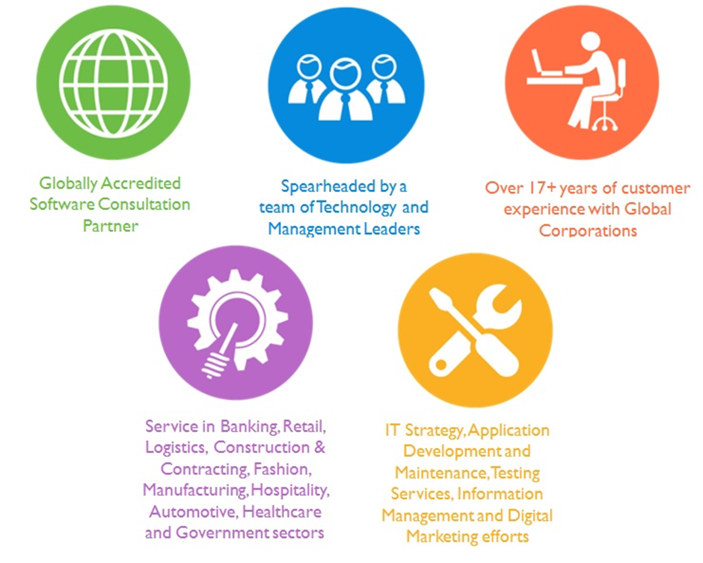

## Key Differentiators

Delivered digital transformation expertise to global customers for over a decade by following industry best practices to maximize ROI for client

Keen technology intelligence combined with aggressive market research to deliver solutions that achieve results with measurable value

Enable access to global consulting expertise with strong local market and business knowledge

Commercial Model that is customizable for your business needs

Services that are designed to optimize applications for improved performance and overall efficiency

1,000,000 plus man-hours of expertise in technology frameworks spanning Microsoft, Open Source, mobility platforms and other proprietary IT technology

Partners top technology vendors to bring in the latest and best services in integration, collaboration, and development

Commercial Model that is customizable for your business needs

Proven Methodologies & Processes

Investment in R & D

Strong Local Presence

Flexible commercial Models

Technology Associations

Software Development Experience

Offshore Development Centre

Quality Assurance & Testing

## Technology & Services



Technology  
&  
Services

Cloud/Traditional Hosting

User Interface & Design

Digital Marketing

Mobility Solutions

Testing Services

Application  
Development

# Functional Specification

## Web Application

|  |
| --- |
| **Annex A Workflows** |
| 01-02 (Re)New Approval for Trade License for Hotel |
| 03-07 Approval for Modification in the building plans |
| 08-09 Primary Approval for Trade License Renewal of hotel |
| 10-11 Primary Approval to Obtain/change Official Trade Name |
| 12-15 Approval to Change in Hotel/Apartment Owner |
| 16 Approval for Hotel/Apartment Operation Resumption |
| 17 Approval for Trade License Cancellation of the Hotel/Apartment |
| 18-19 Approval to Obtain a (Re)New Hotel Management License |
| 20-21 Approval to obtain a (Re)New Tour Operator Trade License |
| 22-23 (re)New Tour Guide License |
| 24 Reprinting/Replacement of Issued Tour Guide License Card |
| 25 Fines Issuance and Collection/Payment |
| **Annex B Workflows** |
| 01 Hotel/Hotel Apartment Inspection |
| 02 Hotel/Hotel Apartment Classification |
| 03 Tour Guide Inspection |
| **Annex C Forms** |
| SCTDA-TS-SRV-1 |
| SCTDA-TS-A001 |
| SCTDA-TS-A002 |
| SCTDA-TS-A003 |
| SCTDA-TS-A004 |
| SCTDA-TS-A005 |
| SCTDA-TS-A006 |
| SCTDA-TS-A007 |
| SCTDA-TS-A008 |
| SCTDA-TS-A009 |
| SCTDA-TS-B001 |
| SCTDA-TS-B002 |
| SCTDA-TS-B003 |
| SCTDA-TS-B004 |
| SCTDA-TS-B005 |
| SCTDA-TS-B006 |
| SCTDA-TS-B007 |
| SCTDA-TS-B008 |
| SCTDA-TS-B009 |
| SCTDA-TS-B010 |
| SCTDA-TS-B011 |
| SCTDA-TS-B012 |
| SCTDA-TS-B013 |
| SCTDA-TS-B014 |
| SCTDA-TS-C001 |
| SCTDA-TS-C002 |
| SCTDA-TS-C003 |
| SCTDA-TS-C004 |
| **Admin** |
| **Master Data Management** |
| Licensing services List |
| Licensing service Fees |
| Licensing service fines |
| Licensing service periods (From - To) |
| Document Upload List |
| Document Requirements per service |
| User Types List (Role) |
| Reject reason codes & descriptions |
| Star Classification list |
| Inspection criteria list |
| Criteria per Service |
| Forms List |
| Inspection Report types / List |
| Violations list |
| User management |
| Manage documents |
| Manage videos |
| Archive Videos |
| Roles and Services (workflow) mappings |
| **Main Modules** |
| **Applicant** |
| Login, Forgot password, Remember Password |
| Registration (basic profile) |
| Multi factor Authentication |
| Email verification |
| Select Service |
| Upload documents |
| Application form |
| Display required documents list |
| Check Violations and Fines (potential Government site integration required) |
| Pay application Fees (Separate from fines) |
| Pay fines (Tahseel integration) |
| Download Documents |
| Receive Star ratings (UI Updates) |
| Receive Notifications |
| Dashboard Updates |
| Raise Disputes |
| **TSD Licensing Staff** |
| Verify document list |
| Manual verification of uploaded documents via visual inspection |
| Approve / Reject Application |
| Send SMS & Email |
| Request Additional Documents |
| Capture comments and results of the verification process |
| Create Inspection report based on results |
| Recommend Initial star ratings |
| **Head Of Inspection** |
| Review Inspector Report |
| Approve / Reject based on inspector Report |
| Schedule On Site inspection |
| Review Requirements based on Video Conference |
| Approval / Rejection Recommendation for Primary Approval |
| Update Inspection Calendar |
| **TSD Manager** |
| Reassign Tasks |
| Approve / Reject Issue of Primary Approval |
| Approve / Reject Tour Guide License |
| Approve / Reject reprint of Tour Guide ID |
| Approve / Reject recommendation for adjusting star rating |
| **Head Of Licensing** |
| Recommend to  TSD Manager for the issuance of Approval to Obtain/Change  Trade Name |
| Recommend to  TSD Manager for the issuance of Approval to Renew/new Hotel Management License |
| Recommend to TSD Manager for the issuance of Approval to Renew/new Tour Operator License |
| Recommend to  TSD Manager for the issuance of Approval to Reprint Tour Guide ID |
| **Mobile App** |
| Mobile App API |
| **System features** |
| Authentication & authorization |
| Auditing & logging |
| Exception handling |
| Manage files and folders |
| Generate thumbnail for videos and images |
| SMS & Email |
| Tahseel Integration |
| Zajel Integration |
| Payment Gateway Integration |
| QR Code Generation |

## IOS Mobile App

|  |
| --- |
| Basic Setup |
| Splash |
| Login |
| Forgot password |
| Dashboard |
| QR code library integration |
| Scanning |
| Create Classification Criteria |
| Create Inspection report |
| Onsite Inspection results |
| Collect evidence 8 forms |
| Retrieve inspection list |
| Obtain Score for Hotel Designator |
| View Assignment |
| Take photo |
| Upload photo |
| Upload documents |
| Submit inspection details |

# High Level Design

## Use case Diagrams

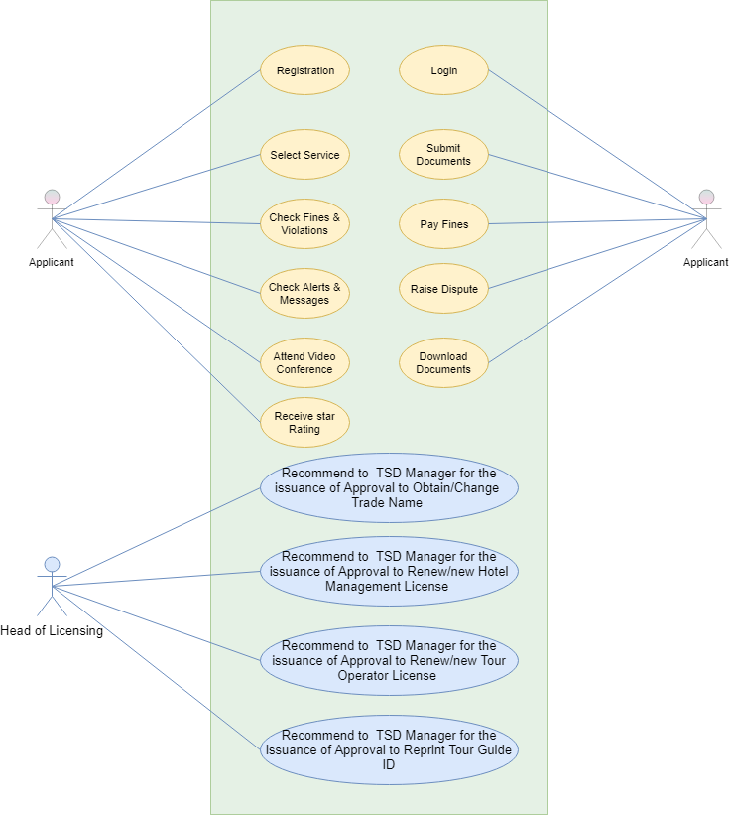

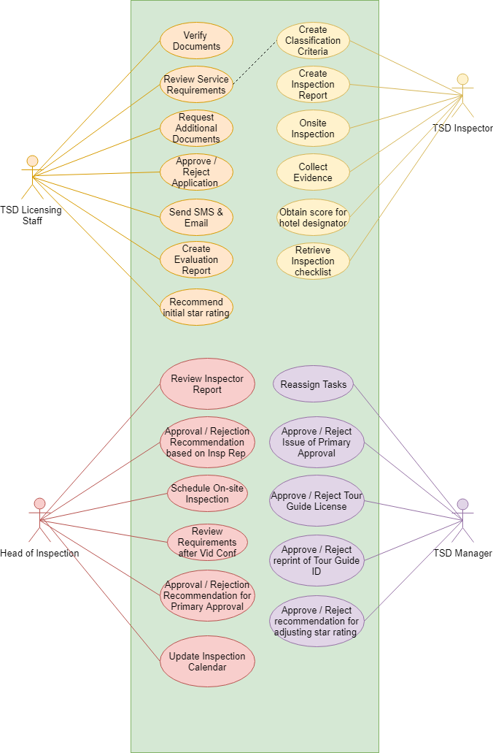

## Data Flow Diagram

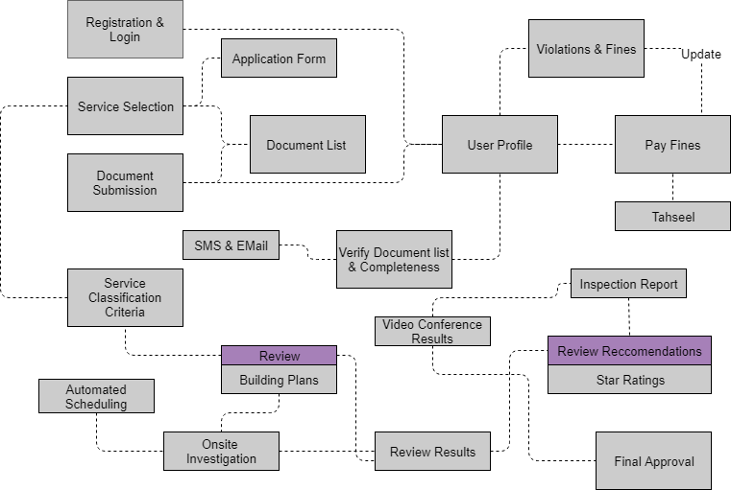

## Workflows

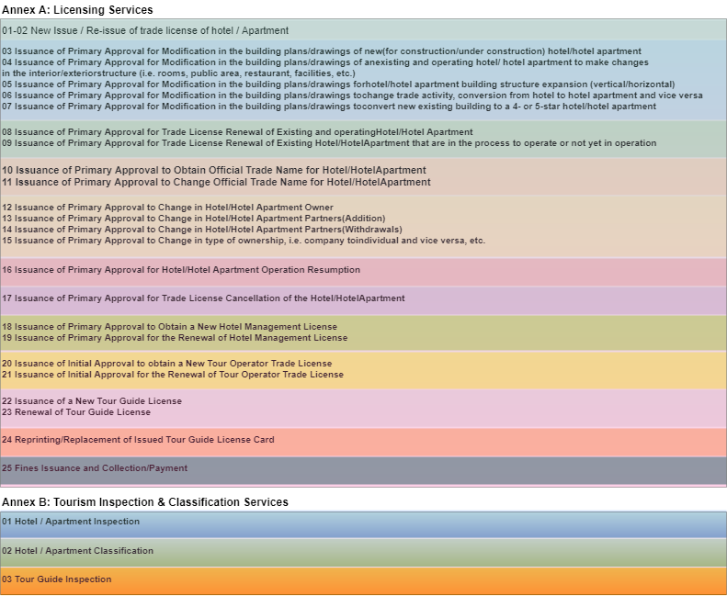

## Generic Workflow

## Functional Architecture

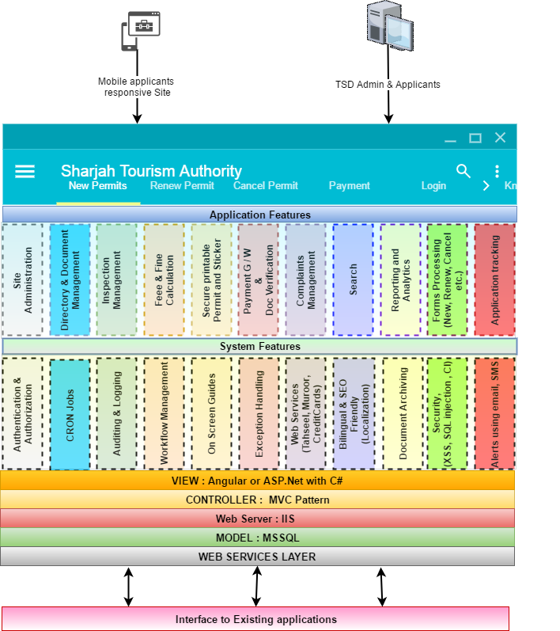

The proposed application is an MVC based application that is technology agnostic. In the section titled “High Level Architecture”, verbat has proposed a reference implementation using .net Application Technologies (more details covered in that section), but this is by no means is a limitation on the proposed technical architecture. The functional architecture depicted above broadly classifies the features of the proposed implementation into “Application” and “System” level features.

System level features are what Verbat considers as non functional requirements while the application level features are functional requirements that were stipulated by the client. Below you will find a run down of the various features that the proposed application will have.

## Application Level features

* Site Administration: An enterprise site administrator will manage various aspects of the site. Site administration consists of activities such as (but not limited to)
  + Adding new users, assigning roles
  + Adding new types of fees and fines for various vehicle violations and permits
  + Configuring gateways
  + Adding new items to the inspection checklist
  + Uploading documents
  + Mining logs to identify system issues
* Directory and Document Management: The application tracks and manages the documents uploaded by the users. Documents are filed into directories (conceptually) that are uniquely identifiable and assigned to the user. Directories may also contain other attachments such as the results of the inspection logs
* Inspection management: This modules keeps a track of all the vehicles that needs to be inspected. The inspector shall be provided with an inspection check list based on the make and model of the vehicle. The inspector shall record the results of the inspection. The results may be accompanied by video, audio or images. These images may be attached to the inspection log
* Fee and Fine Management: Based on the length of time the permit is requested, fees are calculated. Fees and fines are also assessed based on complaints received as well as any violations registered against the applicant or vehicle (by the inspector)
* Printable Permits and Stickers: Barcoded permits and stickers may be printed by the user as soon as they are issued. System will generate bar codes based on some predefined rules. Custom printing on special printers
* Payment gateway and Document Verification: The system allows users to make payments of fees or fines using integrated payment gateways or using Tahseel. On the same note all documents that are uploaded by the applicant can be verified by comparing the information on the documents with Muroor. Both of the above activities will be done in real time by integrating with external systems by leveraging their web services.
* Complaints management: Complaints may be registered on the site by the general public as well as by operators or applicants. This will require a system to manage disputes. Complaints may be categorized and tiered based on urgency and priority. They may then be routed or escalated to the appropriate TSD personal
* Search: An integrated search can be used within various modules to look up applicants, vehicles, complaints etc.
* Dashboard with Reporting: Custom dashboards shall be provided to the various stakeholders of the system. Depending up on their entitlements various reports and analytics will be available.
* Forms processing: The system has various forms (new applicant, reorder prints, cancel permits etc.). These forms have various pieces of functionality/information that are common. Common data management and retrieval techniques will enable the application to be more scalable and adaptable
* Application tracking: Any time during the application process, users will be able to track the progress of their application. TSD managers will be able to query the status of the vehicle inspections near to real time.

## System Level Features

* Authentication and Authorization: The system will validate the identity of the user and then authorize the user and assign a specific role that they have been mapped to by the admin
* Auditing and Logging: The system will log the activity of the logged in user so that it can be tracked for security purposes. The system will also log the actions being performed by the system so that it can identify issues caused by systemic application failures
* Scheduled Jobs: The system will have scheduled jobs running at specific intervals. The scheduled jobs makes it possible to identify permit holders with expiring licenses. These jobs can also be used to automatically disable access for expired licenses as well as send out notifications and alerts to permit holders and TSD staff. Another use would be to archive old documents
* Workflow Management: The application maintains different queue for different roles. When an applicant has fulfilled his application requirements, the system will move the application to the concerned TSD staff. The system will also be smart enough to (Re) assign the application to the TSD manager or inspector based on the action taken by the TSD staff. Workflow will keep track of the different states that the application has gone through so that it can easily be queried by the concerned user
* On Screen Guides: On screen guides provide context sensitive guidance based on the role of the logged in user. Textual hints will also be interspersed across different elements on the site
* Exception Handling: As a part of managing user expectations, exceptions or inadvertent application failures will be handled by providing user friendly and contextual error messages. All exceptions will be logged for future reference so that it can be handled better.
* Web Service integrations: Web service framework to integrate various third party integrations such as credit cards, Muroor, Tahseel etc. will allow for the application to freely exchange information.
* Localization & SEO Friendliness: Localization will allow for the application to be multilingual, so that it can display different currencies, languages and direction of the flow of text.
* Document Archival: An application that must handle a large amount of documents for its various users, must find a way to archive documents that are no longer used or documents that belong to expired accounts. Archival provides a means by which these documents can be securely stored on a resource dedicated for it. Verbat will provide the mechanism for archival, but the client will have to provide hardware or software necessary to fulfil this requirement
* Security: Security of the site is managed through a combination of the logs maintained by the system as well as additional functions such as
  + Secure communication using SSL
  + Password salting
  + Provision to secure the site against Cross Site Scripting attacks (and reflected XSS), SQL Injection attacks, Code Injection , buffer overflow vulnerability
* Messaging: A messaging framework to support communication via email and SMS messages for the various function points in the system.

## High Level Architecture

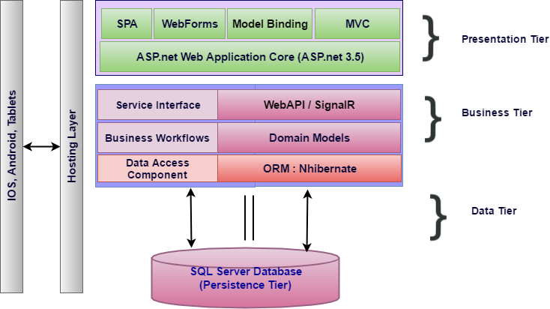

Figure High Level Technical Architecture

The proposed architecture combines the classic MVC architecture along with elements drawn from Service Oriented Architecture (SOA). SOA compliments the requirement where the client’s needs to extend the functionality of the application by retrofitting add-on services in the future.

The business layer represented in the figure above is a service layer that is modelled by the business domain. Hence it becomes easy to contain and isolate workflows. Each service layer results from the culmination of a broad range of granular micro services that work in concert to deliver the desired functionality. If there is a future need for adding new services, this can easily be accommodated by building a parallel pipeline.

Traditionally front end design of .net based applications are done using ASP.net web forms or web pages, but now a days most web applications take advantage of Single Page Applications (SPA) like Angular, a framework that loads a single HTML page and dynamically updates the page as the user interacts with the app. SPAs use AJAX and HTML5 to create fluid and responsive Web apps, without constant page reloads. This is particularly useful, since one of the requirements for the application is a state-full page that supports persistence.

MSSQL is preferred relational database, as per the client. For Rapid Application Development (RAD), most application frameworks employ Object Relational Mappers (ORM). .Net supports both nHibernate as well as Entity framework, both of which are ORM’s. ORM’s support rapid application development by side stepping the work related to managing the intricacies of a relational database. ORM’s also make the application agnostic to database technologies (Such as Oracle, MySql, MSsql etc.).

In order to support portable devices that needs to communicate with the application, Web API’s are implemented and are exposed using restful web services. To enhance and enrich the mobile experience Web services are clubbed with SignalR, a library that simplifies the process of adding real-time web functionality to applications. Real-time web functionality is the ability to have server code push content to connected clients instantly as it becomes available, rather than having the server wait for a client to request new data. This would be of great importance as it will push the latest updates to the handheld devices operated by Inspectors. By doing so the devices could be used both on-line and off-line (Where cell phone reception is bad)

# Nonfunctional Requirement (Others)

|  |  |
| --- | --- |
| **Requirement** | **Details** |
| User Experience and  UI Design | * The application will be developed only in English and Arabic * The layout and graphical components will be created considering the usability factors |
| Performance | * Application will allow users to have smooth and quick access to the information or services they require. |
| Security | * The system will be protected against attempts of security breaching that may arise. * Web security standards will be followed. |

# Assumptions

The project solution and technology is created from the initial understanding of the requirement shared with Verbat through mails and meetings. The proposed solution is based on the following assumptions:

* Client to provide Verbat with the branding guidelines.
* The proposed application front end and backend would be in English
* Client will purchase the necessary templates needed for development
* Client shall provide licensed images and logos in specified size & format
* Super Admin can manage all the users within the application.
* Requirements should be well defined, agreed and signed-off by the client
* Internet connectivity is required for the functioning of the web application.
* Customer will procure templates, SSL certificates & Payment processor
* UI development effort is 2-4 hrs. per screen
* Reporting and analytics may require external tools. Current assumption is that analytics will be minimal and simple.
* Testing will be done in latest versions of Google Chrome, Mozilla Firefox & IE web browsers only
* Development Contingent upon timely feedback from client
* Print formats for stickers and permits will be provided by the client and printing will be done on blank paper sheets (Not printed paper)
* User manuals in Arabic shall not be provided by Verbat
* Client will provide relevant information regarding Integration with external systems like Tahseel, Zajel etc. (to Verbat’ s satisfaction)
* SMS and Email gateways shall be provided by the client
* Client shall provide detailed information regarding Integration with hotel statistics system
* The workflow diagrams represented in this document is an approximation of the workflow descriptions provided by the client. The actual requirements shall vary based on the requirements collected.
* For the sake of simplicity complex workflows have been simplified and may not contain all the actors or processes
* The RFP clearly states that it does not cover all of the details needed for the service provider to make an accurate estimation. The estimate provided is with reference to the information provided by the client. If Verbat finds during the requirement gathering phase that the actual requirements uncovered are different form the original and thus might affect the estimates provided, it shall exercise rights to renege on the contract

# Out of Scope

With the ever evolving digital market, the requirement needs should be clear to both the parties involved, hence the importance of mentioning the out of scope details of the project. Following are considered to be out of scope while creating this proposal.

* Purchase of images, fonts
* Adding new features to the application other than mentioned in the functional specification.
* Any language other than English
* Manual data entry
* Hardware Integrations / procurement and purchase
* Database migration
* Content writing
* Content or image procurement or uploading or editing.
* Hosting Infrastructure and Maintenance
* Annual Maintenance of the application (Bug fixing, debugging) - For AMC details, please refer section titled “Maintenance and Support”
* Physical deployment at client’s site
* Backup solution and Disaster recovery
* The Service Provider shall NOT migrate the data from the current solution to the new solution

# Technology Solution

## Proposed System Environment



IIS..Net 4.5  
MSSQL

MVC / C# / XCODE

HTML / CSS3

**MS SQL2012  
Windows 8/10  
Web Services**

## Technical Configurations

### Development Tools

* Visual Studio, MVC, C#, XCODE, Objective C
* MSSQL
* HTML / CSS 3
* Ajax, JavaScript, JQuery

### Recommended Web Hosting Package

* Medium CPU power – single to dual CPU
* Single Domain
* Windows Sever 2012R2 Data Center
* Disk Space: 5 GB
* Monthly Bandwidth: 10 GB
* Web site Server Software – IIS 8.0

### Browser Compatibility

* Chrome version: 56
* Firefox version: 51
* Edge version: 39

### Hardware Interface

**Desktop**

The application is reliant on hardware interfaces to provide a seamless automated user experience.

* Computer with Windows 8 or 10 OS
* Compatible Browsers as specified in section 7.2.3

# Commercials

## Web Application

|  |  |  |
| --- | --- | --- |
| **No** | **Description** | **Amount (USD)** |
| 01. |  | 00,000.00 |
| 02. |  | 00,000.00 |
|  |  |  |

*Note:*

* *The above cost does not include Application hosting, integration, Project Management or deployment*
* *For change management cost, please refer to section 10 titled Change Management*

## Payment Terms

* Payment terms
* Payment terms
* Payment terms

*Note: Payment should be made within 7 days from the date of the invoice*

## Mode of Payment

By Cheque / DD to Verbanet Technologies LLC

OR

Wire transfer to our bank account

Bank Name : Emirates NBD

Account Name : Verbanet Technologies LLC

Account Number : 1011492858201

IBAN Number : AE61 0260 0010 1149 2858 201

Swift Code : EBILAEAD

Bank Address : Mamzar Branch, Dubai

*Note: Bank charges incurred during wire transfer to be borne by the client. Any local taxes applicable to be borne by the client*

# Delivery Management

## Project Management

The Verbat development center strictly follows industry standards on quality. The project management is process governed by the Verbat Quality Management system and is put to verification through internal audit programs that happen from time to time.

Verbat will dedicate a project manager for the proposed implementation. Verbat proposes Client to identify one project manager who will be driving activities to be undertaken by Client to be the single point of contact for Verbat.

## Roles and Responsibilities

Verbat will assign a dedicated Project Manager/Project Lead to lead the project, who will be the first point contact for Client. He/she will be responsible for planning and managing the various activities within the project. He/she will work closely with Client Project Manager, to give periodic status updates and ensure high level of visibility and comfort on the progress of the project.

The Project Manager/Project Lead will lead the co-ordination between Verbat and Client, thus enabling smooth transitioning of Client requirements to the Verbat’s offshore delivery team, and provide visibility as well as comfort on the progress of the services to Client.

He/she will have periodic meetings with Verbat’s Senior Management, thus ensuring Verbat’s Management commitment and focus on Client initiatives.

## Delivery Activity Summary

|  |  |
| --- | --- |
| Activities | Description |
| Detailed requirement Analysis | Verbat team to conduct detailed study of requirement for the phase. If clarification is required, team will reach out to Client for more information and/or time for discussions. |
| DB Design | DB design for central and test DB. |
| Software Requirement Specification document (SRS) | Once the requirement analysis is completed, Verbat team will submit the SRS document for approval |
| UI/UX Design, Prototyping | Based on the SRS, Verbat UX/UI team will work on the UI/UX of the screens and submit a prototype for approval |
| Functional Specification Document (FS) | Once the Prototype. UI/UX is approved, Verbat shall submit an FS document for approval. |
| Development | Actual system development starts based on the FS. This involves detailed design and software development of Web Application. |
| Testing | Test Planning, test plan creations, internal, integration testing and user acceptance testing. |
| Deployment | Deploying the latest built in the Verbat Test Server. |

## Project Implementation Plan

Verbat will be providing the solution in a stand-alone fixed bid approach which ensures minimum viable solution for quick wins with core focus on the long-term business objective and outcome. Once the implementation is over, Verbat will initiate the application maintenance process (once the maintenance contract is signed) which continues to extend after the implementation.

## Deliverables

|  |  |  |  |
| --- | --- | --- | --- |
| No | Deliverable | Description | Timeline |
| 1 | Weekly updates | A weekly update email/report shall be sent to project team in SCTDA to update them with the status of the Solution | Weekly |
| 2 | Solution User Guides | Comprehensive end user guide and technical documentation in English language for both types of users end (hotels) and admin (SCTDA) | Upon Project completion |
| 3 | LCS Solution | The full functioning Solution with the above mentioned requirements | Due Date |
| 4 | Source Code | Fully functioning source code of the Solution, Database, Inspection iOS app, and reporting with all licensing and keys. The source code must be editable completely by any third party without the need to refer to the Consultant, along with its technical documentation | Upon Project completion |
| 5 | Training workshop | Organize and provide training to the different users of the Solution | Upon Project completion |

## Estimated Delivery Time

**UAE working days for prototype from the date of Approval of the project (LPO/Signed proposal) with advance payment: 15 working man days**

**UAE Working days for the development of the application from the Date of Approval of the Prototype: 7.5 working man months**

| **Activity** | **Deliverables** | **Timeline** |
| --- | --- | --- |
| Project Initiation | Scope Document, Project plan |  |
| SRS | System Analysis & User Specification, Updated project plan, prototype |  |
| Prototype  (parallel stream ) | Working prototype |  |
| Development | Working Application |  |
| Testing | Testing scenarios |  |
| Deployment | Tested Web, Tablet & Mobile  Application in IOS, Source Code |  |

## Deployment Details (at Clients Behest)

* Client can opt for hosting the application at Verbat’s Server.
* If deployment is at the client’s server, responsibility of deploying the application onto the production environment after conducting the necessary acceptance testing will lie with the client unless and until Verbat’s support is contracted for deployment.

***Note****: Hosting the application at Verbat’s server will call in for additional charges.*

## Release Planning

* Client will be informed about the release date and time through email.
* Client performs the UAT

## Risk and Contingency Planning

Verbat has identified various risk factors associated with this assignment and understands the impact of these risk factors on the project schedules. The objective of this section is to highlight for both Verbat and client, the risk factors, to analyze the impact of the risks on project execution, and to propose strategies to control and reduce the impact of the risk factor.

These various risks, which could arise during the project, are tabulated below along with mitigation implementation.

| Type of risk | Impact | Risk Mitigation | Risk Handling |
| --- | --- | --- | --- |
| Scope Creep | H | Functions and features will be detailed in system requirement documents and will go through client approval. Once this document is approved, any change to requirement will go through change management review for possible impact assessment. | Proper change management procedure will be implemented. |
| Delay in customer feedback | H | The plan is prepared with enough lead-time for customer reviews and approvals.  The customer is indicated with the dates when the document is expected after review and approval. | The request for feedback will be escalated if not attended at the right time so that the schedules are not affected. Deemed acceptance criterion is set up front and will be followed. |
| Non-availability of necessary software’s, frameworks, database instances and infrastructure at client’s hosting environment(If hosting support is provided by Verbat) | M | Client will be informed in advance on these requirements. | Possible impact to schedule. |
| Manpower attrition | L | All efforts would be made to ensure process dependence rather than being person dependent. As a risk mitigation plan Verbat will train backups. | A new person will be identified as early as possible, provided the required project-specific training and mentored by the senior members of the team to minimise impact of attrition on the project. |

*H-High, M-Medium, L-Low, NA-Not Applicable*

# Change Management

Any addition which comes out of the project scope, upon and after the launch of the tool will be considered as change management. Verbat recommends the following change management procedure for the same.

* Any change which comes out of the project scope, which was discussed, documented, and mutually approved by both the parties in the requirement stage, will be carried out only through raising a change request.
* Change request will be studied and an impact analysis on the existing work flow will be performed.
* On finalizing the impact, effort estimation for the change will be calculated and raised as additional requirement.
* Verbat will initiate the change request only after getting a formal approval from the client for the additional changes raised.
* Any change from the scope will be charged at **USD ----- per man day effort** and approval from the clients will be availed before commencing on any change management.

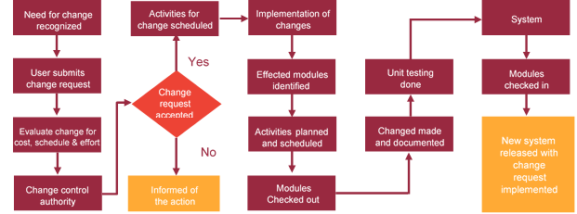

# Miscellaneous

## Acceptance Criteria

* UAT sign off should happen within 7 Days from the release of the application/ Phase and the acceptance confirmation needs to be mailed to Verbat failing which Verbat will consider the project as approved by the client.
* Any comments or reason for rejection need to be documented and the same needs to be sent as an email from the official mail id of client to Verbat.

## General Terms and Conditions

* An average of 20 working days are assumed in a month
* All the projects activities will be carried out from our off-shore development center in India
* The scope of the project is to develop the Application as detailed in the scope of the project and mentioned in this proposal. Any changes or additions will have to go through change management.
* This proposal and all technical/ functional specifications have been derived or concluded from the data shared via email / information's transferred during the initial requirement analysis meetings and conversations. Verbat reserves the right to amend the terms of this proposal, should the SOW terms, functional features and functionalities change during the course of the project
* Application will be best viewed only in the environment mentioned in the section 7.2.3
* All the documentation will be provided in English.
* Third party components may be used to develop this application.
* All Source Code and other project artefacts would adhere to the Verbat document templates and internal coding standards
* Acceptance criteria shall be based on the clauses which were mutually discussed between Verbat and client at the Requirement Analysis phase and the same will be documented and approved by both parties through official emails
* In case Client requires any extension of the proposed acceptance schedule, the associated effort and cost of such extension can be mutually reviewed.
* For any circumstances if project needs to be put on Hold / Stop it requires minimum request notice period of 1 week along with duration for which request will be addressed by management and final decision on the request will be based on that
* If deployment is done in client’s server, Verbat cannot be held responsible for any performance issues arising due to hardware malfunctions.
* Client is responsible for data backup in case the application is not hosted on Verbat server.
* Source code will only be delivered or uploaded on the Production Server once the due payments are made.

## Assumptions and Dependencies

* Detailed system study is required before the start of the project.
* During the requirement gathering phase, authorized personnel from the Client’s side is expected to be available for discussion and finalizing the HLD (High Level Design), before development commences.
* Type of reports and formats, if under the scope of the project, needs to be specified by Client before project sign off.
* Workflows if under the scope of the project, need to be specified/ confirmed by client before project signoff.
* All queries regarding the client requirement and any queries which may hinder the project advancement at any stage should be answered by the client within 24 hours from the time of initiation, failing which the time delay will get added to the actual effort which was estimated.
* Verbat assumes that all sign-offs from Client will be provided within agreed and specified timeframe.
* Client will provide all the necessary contents, both text and image, before starting the project in the format suggested by Verbat (if any).
* The client should provide the relevant information and data well in time for the execution of a related activity. Non- availability of this information or data may lead to an interruption of work which may result in a delay in delivery as well as additional costs to the client.
* Client should have/possess server with technical specifications as suggested by Verbat for the proposed application.

## Source Code & Intellectual Property Rights

* Upon completion of the Project and 100% completion of the payment, client will have access to the source code except for propriety codes, developer tools and third party application etc.
* The solution offered will be the intellectual property of the client and will be made available to the client on an “unlimited license” basis.
* Modifications by third party/person: No person or organization, other than Verbat or any person authorized by Verbat in writing, has any permission to modify/change the software Solution to be eligible to get continued support from Verbat as per the support terms defined under this document.
* Liabilities/Damages: Verbat accepts no liability or damages of any kind arising out of use or non-use of the software delivered. The responsibility of testing of software lies with Client.

## Maintenance & Support

* Maintenance contracts by default are supported as per the basic SLA terms.
* **AMC with Basic SLA is charged at 20 % of the total project value**. Additional Effort/change management request will be added towards Total Value of the Project to determine the AMC value.
* Maintenance support is limited to providing application support for ensuring the consistency of the look-and-feel, bug fixes and user issues i.e. maintenance and support of the existing features of the application.
* Support does not in any way cover providing technical or other support to the end users. The maintenance agreement does not include functionality changes or feature additions which are handled as change requests which will be charged AED 1200 per man day. AMC does not include server support, maintenance and application deployment.
* AMC charges will cover Off-Site Support and Debugging. Support includes E-mail, Telephone and Chat unless explicitly specified. In the event, the application is hosted with the client; necessary remote desktop connectivity should be provided for carrying out maintenance activity.
* Gap in AMC - In case if the client does not opt an AMC for a year and want to renew it after that period, 50% of the AMC amount for the year for which AMC is not taken will also be payable if the client wishes to renew the AMC contract.
* Note:
  + Please note that the AMC support shall start only after all the necessary sign-offs (AMC Document) to this effect have been given.
  + It is not mandatory that the client should opt for an AMC. The client will still be supported on an ad-hoc basis on an agreed man-day rate.
  + AMC Payment Terms: 100% to be paid as advance.

## Service Level Agreement

|  |  |  |  |  |
| --- | --- | --- | --- | --- |
| **Key** | **Max Response Time** | | **Max Resolution Time** | **Target** |
| Basic | 1  working day | 3 working days | | Request / incident / problem tickets |
| Advanced | 5 Business Hours | 12 Business Hours | | Request / incident / problem tickets |
| Priority | 3 Business Hours | 5 Business Hours | | Request / incident / problem tickets |

Note:-

* We provide Basic SLA as standard with AMC while Advanced and Priority SLAs attract additional charges.
* Time zone applicable as per India time zones (3:30 AM GMT to 12:30 PM GMT- Monday to Friday).

# Our Clients

**UAE University**

Education

Transportation

**Canada Cartage**

Construction

Services

Finance

We look forward to hearing from you soon and hope that you will give us the privilege to work with you in meeting your business goals. Thank you.

Thank You



©   
1999 - 2017. All Rights Reserved   
Verbanet Technologies LLC  
www.verbat.com